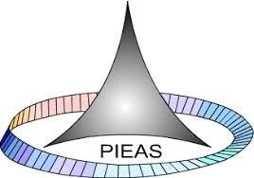

PAKISTAN INSTITUTE OF ENGINEERING AND APPLIED SCIENCES

***Computing Fundamentals & Programming***

**FALL 2020**

Laboratory Exercise-11

Department: Physics

Name: Umar Shifaqat

Serial No. 43

Roll No. BS-20-GB-100864

Date: DECEMBER 20, 2020

**HOME TASKS**

**HOME TASK 01**

**INPUT**

#include<stdio.h>

int fact(int num);

void main()

{

int number,factorial;

puts("Enter a number to find its factorial:");

scanf("%d",&number);

factorial=fact(number);

printf("The factprial of %d is %d ",number,factorial);

getchar();

getchar();

getchar();

}

int fact(int num)

{

if(num==1)

return 1;

else

{

num*=fact(num-1);

return num;

}

}

**OUTPUT**

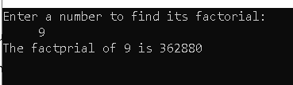

**HOME TASK 02**

**INPUT**

#include<stdio.h>

#include<stdlib.h>

void show(int mat[10][10],int r,int c);

void multiply(int r1,int c1,int r2,int c2,int m1[10][10],int m2[10][10],int res[10][10]);

void main()

{

int r1,r2,c1,c2,i,j,k;

int mat_1[10][10];

int mat_2[10][10];

int mul[10][10]={0};

printf("Enter rows and columns for 1st matrix respectively: ");

scanf("%d%d",&r1,&c1);

printf("Enter rows and columns for 2nd matrix respectively: ");

scanf("%d%d",&r2,&c2);

if(r2!=c1)

{

puts("Matric multiplication is not possible");

getchar();

getchar();

getchar();

exit(0);

}

puts("Enter elements in 1st matrix:");

for(i=0;i<r1;i++)

for(j=0;j<c1;j++)

scanf("%d",&mat_1[i][j]);

puts("Enter elements in 2nd matrix:");

for(i=0;i<r2;i++)

for(j=0;j<c2;j++)

scanf("%d",&mat_2[i][j]);

puts("\nThe 1st matrix is:");

show(mat_2,r2,c2);

puts("The 2nd matrix is:");

show(mat_1,r1,c1);

puts("\nThe result of matrices multiplication is:");

multiply(r1,c1,r2,c2,mat_1,mat_2,mul);

show(mul,r1,c2);

getchar();

getchar();

getchar();

}

void multiply(int r1,int c1,int r2,int c2,int m1[10][10],int m2[10][10],int res[10][10])

{

static int i=0,j=0,k=0;

if(i>=r1)

{ return; }

else

{

if(j<c2)

{

if(k<c1)

{

res[i][j]+=m1[i][k]*m2[k][j];

k++;

multiply(r1,c1,r2,c2,m1,m2,res);

}

k=0;

j++;

multiply(r1,c1,r2,c2,m1,m2,res);

}

j=0;

i++;

multiply(r1,c1,r2,c2,m1,m2,res);

}

}

void show(int mat[10][10],int r,int c)

{

int p,q;

for(p=0;p<r;p++)

{

for(q=0;q<c;q++)

printf("%d ",mat[p][q]);

printf("\n");

}

}

**OUTPUT**

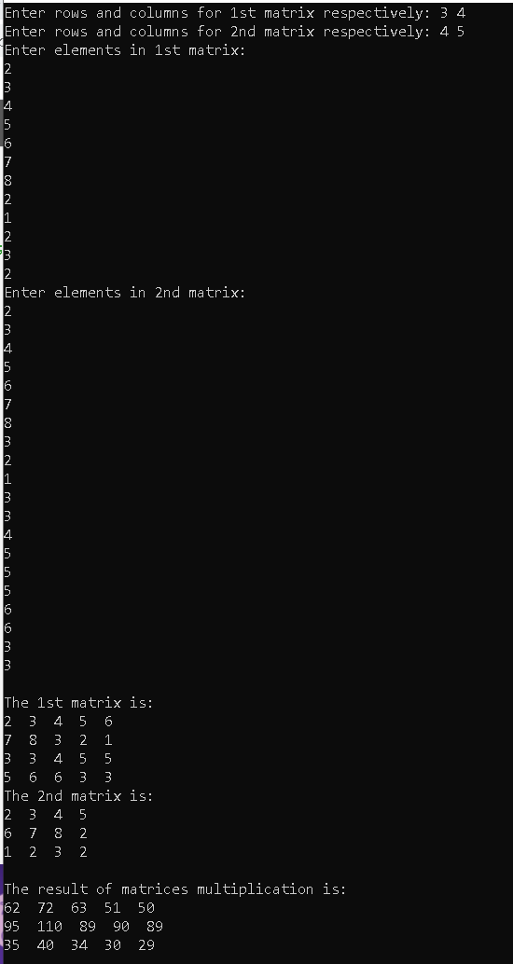

**HOME TASK 03**

**INPUT**

#include<stdio.h>

int sum(int x);

void main()

{

int number, sum_of_numbers;

puts("Enter a number: ");

scanf("%d",&number);

sum_of_numbers=sum(number);

printf("The sum of numbers from 1 to %d is %d",number,sum_of_numbers);

getchar();

getchar();

getchar();

}

int sum(int x)

{

if(x==0)

return 0;

else

return x+sum(x-1);

}

**OUTPUT**

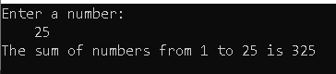

**HOME TASK 04**

**INPUT**

#include<stdio.h>

void check(int mat[10][10],int r,int c);

void show(int mat[10][10],int r,int c);

int upper=1;

void main()

{

int r,c,i,j;

int mat[10][10];

printf("Enter rows and columns for 1st matrix respectively: ");

scanf("%d%d",&r,&c);

puts("Enter elements in matrix:");

for(i=0;i<r;i++)

for(j=0;j<c;j++)

scanf("%d",&mat[i][j]);

puts("\nThe matrix is:");

show(mat,r,c);

check(mat,r,c);

if(upper==1)

puts("\nThe matrix is upper triangular");

else

puts("\nThe matrix is not upper triangular");

getchar();

getchar();

getchar();

}

void check(int mat[10][10],int r,int c)

{

int i,j;

for(i=0;i<r;i++)

{

for(j=0;j<c;j++)

{

if(mat[i][j]!=0&&i>j)

upper=0;

j++;

}

}

}

void show(int mat[10][10],int r,int c)

{

int p,q;

for(p=0;p<r;p++)

{

for(q=0;q<c;q++)

printf("%d ",mat[p][q]);

printf("\n");

}

}

**OUTPUT**

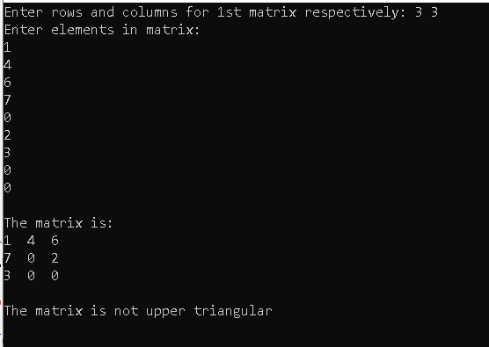

**HOME TASK 05**

**INPUT**

#include<stdio.h>

int dig=0;

int digit(int num);

int main()

{

int number,digits;

puts("Enter a number: ");

scanf("%d",&number);

digits=digit(number);

printf("The number of digits are %d",digits);

getchar();

getchar();

getchar();

return 0;

}

int digit(int num)

{

if(num>0)

{

dig++;

return digit(num/10);

}

else

return dig;

}

**OUTPUT**

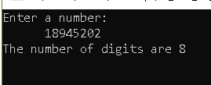

**HOME TASK 06**

**INPUT**

#include<stdio.h>

int digit(int num);

void main()

{

int number,sum_of_digits;

puts("Enter a number: ");

scanf("%d",&number);

sum_of_digits=digit(number);

printf("The sum of digits is %d",sum_of_digits);

getchar();

getchar();

getchar();

}

int digit(int num)

{

if(num!=0)

return (num%10+digit(num/10));

else

return 0;

}

**OUTPUT**

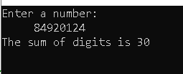

**THE END**